Notes
Items in italics have not been developed yet.
All items may be subject to change.
Dimensions are maxima and include PCB standoffs etc.
All field connectors will be pluggable ‘Phoenix’ Type and take up to 1.5 mm CSA wires.

Cabinets

Each Module Window can accept two Modules
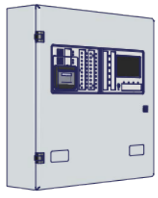
ZBOXS Standard Shallow for small batteries, 1 x Module Window, 2 x 17 Ah, 450w x 462h x 131d
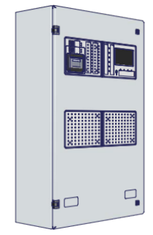
ZBOXM Medium Deep for large batteries, 2 Module Windows, 2 x 38 Ah or 2 x 12 Ah on side 450w x 720h x 206d
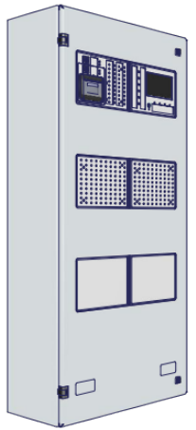
ZBOXL Large Deep for large batteries, 3 x Module Windows, 2 x 38 Ah – 2 x 12 Ah on side, 450w x 960h x 206d
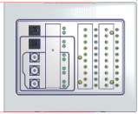
ZBOXMODS Surface Single Module back box (used with plastic bezel) 214w x 177h x 57d
ZBOXMODF Flush Single Module back box (used with plastic bezel) 176w x 162h x 57d
? Single Module long link (for assembling Single Modules one above another)
? Single module short link (for assembling Single Modules side by side)
Note: if single modules are assembled in a “square” there will be a “hole” in the centre.

Document box

.
Bezels and doors

ZBEZS Standard flush metal bezel 30mm all around, 492w x 504h x 30d
ZBEZM Medium flush bezel metal 30mm all around, 492w x 762h x 30d
ZBEZL Large flush bezel metal 30mm all around, 492w x 1002h x 30d
Note that these may change to ‘picture frame’ design
ZBEZDS/SS Small stainless steel bezel or standard special finish bezel with glazed door, 687w x 623h x 71d
ZBEZDM/SS Medium stainless steel bezel or standard special finish bezel with glazed door, w x h x d
ZBEZDL/SS Large stainless steel bezel or standard special finish bezel with glazed door, 687w x 1101h x 71d
SPECIAL Standard stainless steel bezel or standard special finish bezel with glazed door, contains single module box 365w x 315h x 71d
ZBEZMOD Module bezel (plastic) 214w x 177h x 15d
ZRMW Pair standard rack mounting wings
? Pair medium rack mounting wings
? Pair large rack mounting wings

Internal chassis
ZCHA1 Stepped chassis, 407w x 175d x 113h (Includes 2.5mm for stand-offs) - PSU behind step, one Main 2-Loop PCB and one A-Bus PCB, PCBs fit in chassis.
ZCHA2 Flat chassis, 407w x 175d x 113h (Includes 2.5mm for stand-off s) - one Main 2-Loop PCB and three full-size A-Bus PCBs, PCBs fit in chassis.
ZRAIL Plastic mounting rails for A-Bus PCBs 19w x 160h x 17d (Protrudes 2 mm below metalwork).
ZSO Single plastic stand-offs for Main 2-Loop PCB 8w x 8h x 16d (Protrudes 2.5 mm below metalwork).

EN 54-4 PSUs

Caged for German market but not UK and others
5A EN 54-4, 173w x 143h x 66d
EN 54-4 Remote Module PSU with connector for Hi-Net PCB (BF360-24, BF 362-1.5 or BF 362-5)

BF362-5/C 24V 5A EN54-4A2 power supply pcb ONLY Batts min 7 Ah max 18 Ah

BF362-5/E 24V 5A EN54-4A2 power caged PSU Only Batts min 7 Ah max 18Ah

BF360-24/C 24V 1.5A EN54-4A2 power supply pcb ONLY batts min 2 Ah max 3.4Ah

BF362-1/C 24V 1A EN54-4A2 power supply pcb ONLY Batts min 2.5 Ah max 19 Ah

Modules

Z41 4.3 inch Control-Display module
Features:

1 microprocessor

4.3”, 95x55mm, 472 x 248 pixel, 24 Bit, 16 M colour resistive LCD touch screen

40 characters of custom text per device

S-Key Key-switch
Mandatory LEDs 1 green, 3 red, 12 yellow
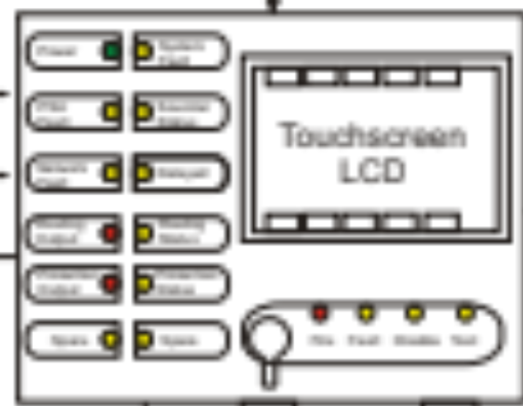
Galvanically isolated mini-USB for programming
2 GB Micro SD (max 16 GB)

Z42 5.5 inch Control module – Not being developed

Z43 Ethernet PCB Half size w x h x d

1 microprocessor

Up to 3 Indication-Switch Modules per control module – all 160w x 120h x 25d

These modules do not have microprocessors
Z44 20-zone Indication Module with name slots
Z45 20-zone Indication Module, name slots & space for 5 switches & 10 LEDs
Z46 20-zone Indication Module, name slots, printer* & space for 2 switches & 4 LEDs

Z47 40-zone Indication Module with name slots
Z48 40-zone Indication Module with space for 5 switches & 10 LEDs

Z49 40-zone Indication Module with printer* & space for 2 switches & 4 LEDs
Z50/1-100 100-zone Indication Module, numbered 1-100
Z50/101-200 100-zone Indication Module, numbered 101-200
ZBLANK Blank Module
Z51 *Printer Interface-PSU PCB, 75w x 120h x 30d
Z52 *Thermal Printer, 80w x 70h x 20d

Miscellaneous

ZKS Key switch for Module – Definitely necessary

ZPB Push button for Module – we are not sure if this will be necessary

ZPT Toggle switch for Module – we are not sure if this will be necessary

Loop PCBs

Z02MAIN/X - ZFP Main 2 loop PCB

Features
145w x 160h x 45d
1 microprocessor
Loop 1 & 2
Apollo XP95 (126 devices) or CAST (? devices) - not both at once
EN 54-4 PSU input
24 VDC 500 mA monitored power output
4 x 1A 6K8 monitored sounder circuits (3A limit),
1 x volt-free general fault relay, 2 x programmable relays – all 1A 24 VDC C/O
2 x programmable 6K8 monitored N/O inputs
RS232 pager-DECT port (ability to handle Quantec as well is with Transmitter)
RS 485 A-Bus port
A-Bus power output

Z02EXT/X - ZFP Main Extender PCB

Features
145w x 160h x 45d
1 microprocessor
Loop 5 & 6
Apollo XP95 (126 devices) or or CAST (? devices) - not both at once
EN 54-4 PSU input
24 VDC 500 mA monitored power output
4 x 1A 6K8 monitored sounder circuits (3A limit),
1 x volt-free general fault relay, 2 x programmable relays – all 1A 24 VDC C/O
2 x programmable 6K8 monitored N/O inputs
RS232 pager/DECT port (ability to handle Quantec as well is with Transmitter)
RS 485 A-Bus port
A-Bus power output

Z02LOOP/X - ZFP 2 loop PCB

Features
w x h x d
? microprocessor
Plugs on to Main 2 loop pcb
Loop 3 & 4 or loop 7 & 8

Compact Controllers (Repeater panels?)

ZREP1F - ZFP HINET (Hi-Net?) Compact Controller, flush

ZREP1S - ZFP HINET (Hi-Net?) Compact Controller, surface

ZREP2F - ZFP Standard (S-Net?) Compact Controller, flush

ZREP2S - ZFP Standard (S-Net?) Compact Controller, surface

Made up from:
Shallow or deep module box
Bezel
Control-Display module
Hi-Net or S-Net pcb
Needs 24 VDC EN 54-4 PSU – if this is derived from a panel, diverse routing is needed, but is not currently supported

Networking

A-Bus RS 485 peripheral PCBs (connect to Main 2-Loop PCB or Hi-Net+ PCB)
Cabling is 2 core + screen plus 2-core for power supply, which may be local.
Up to 15 per Network PCB – half-size 80w x 70h x 30d – full-sixe 80w x 150h x 30d

Powered from Main 2-Loop PCB or other EN 54-4 PSUs
Normally only used within the cabinet(s) but may be extended up to 1 km for non EN 54-2 functions
1 microprocessor each
Z11 4 relay PCB (half-size)
Z12 8 relay PCB
Z13 8 I/O PCB (half-size)

Z14 16 I/O PCB

Z15 4 Sounder PCB with PSU monitoring - 4 x 1A 6K8 monitored sounder circuits (3A limit),

Z16 4 Detection zone PCB (conventional) with 2 sounder circuits and PSU monitoring - 2 x 1A 6K8 monitored sounder circuits
Z17 Mimic Interface PCB (will use light guides) How many LEDs – what colours?

B-Bus RS 485 peripheral PCBs (connect to Main 2-Loop PCB only)
Cabling is 2 core + screen plus 2-core for power supply, which may be local.
Up to 15 per Main PCB – half-size 80w x 70h x 30d – full-sixe 80w x 150h x 30d

Powered from Main 2-Loop PCB or other EN 54-4 PSUs
Normally only used within the cabinet(s) but may be extended up to 1 km for non EN 54-2 functions
1 microprocessor each
? IFAM FAT German indicator interface PCB
? IFAM FBF German control interface PCB
Z18 German key box interface PCB
ATE (Alarm Transmission Equipment) interface PCB
TAS pcbs
? XBE1 BMA interface
? XBC1 BMA interface
? TLA1a TAS-Link II a/b

C-Bus RS 232 peripheral PCBs (connect to Main 2-Loop PCB only)
Peripherals are not EN 54.
Cabling is 2 core + screen plus 2-core for power supply (If 24V), Or use own PSU.
Up to 1 per Main PCB

May be powered from Main 2-Loop PCB (if correct voltage) or own PSU
Normally external to the cabinet(s) and may be extended up to 10 m.
Third-party Pager Transmitter
Third party DECT telephone interface

High Integrity Network (Hi-Net)

Cabling is 2-core + screen, power supply is always local
Galvanic isolation of network
Max 64 Hi-Net nodes per system
ZHN RS 485 Hi-Net PCB (for Main 2-Loop PCB) w x h x d

1 microprocessor
ZHN+ RS 485 Hi-Net+ PCB (For direct connection of A-Bus PCBs) w x h x d

1 microprocessor

Standard network (S-Net)
S-Net may be a selectable option on a Hi-Net PCB – but note the reduced number of nodes.
Cabling is 2-core + screen, power supply is always local
Galvanic isolation of network
Max 32 S-Net nodes per system
ZSN RS 485 S-Net PCB (for Main 2-Loop PCB) w x h x d

1 microprocessor
ZSN+ RS 485 S-Net+ PCB (For direct connection of A-Bus PCBs) w x h x d

1 microprocessor

Interconnects
ZLOOM1 34-way IDC (Control module to Main 2-Loop PCB)
ZLOOM2 6-way IDC (Control module to Printer Interface-PSU)
ZLOOM3 8-way IDC (Control module to Indication-Switch Modules)

PC Software

ZTOOLS PC Tools – English

ZLOG PC Logging software for end users

Features

Very user-friendly colour LCD touch-screen interface
Very complex cause and effects possible
Micro SD memory can be removed for off-site configuration (too easy to remove)
Programming via USB port on control module
Thermal printer paper can be loaded without opening the cabinet

The printer assembly can be replaced without opening the cabinet

The LCD will identify the product version when in alarm state to aid tech support

Installer logo, name, phone and web address can be shown on the LCD

Real Time Clock has automatic daylight saving function (BST/GMT etc.)

Up to 200 zones per control panel

Up to 10,000 programmable and indicatable system zones

Greater than 100,000 addressable device system capacity
20,000 filterable event memory (fire, fault, system & supervisory event)
Simple selection of supported languages – currently English with German to follow)
Slide-in label system and templates for indication and switch modules

Internet connectivity

Internet connection via optional Ethernet port PCB
Internet functionality TBA but the following are being considered.

Emailing of events
Ability to review programming, cause and effects and alarm status
If provided, the ability to make changes remotely will still require a site engineer

Configuration

Full functionality will require the PC Tools
Functions available from the control module will include:
Loop learn
Add/modify/remove device
Show fitted devices

Repeaters and remote modules
The cabinet for remote modules and repeaters has not been designed yet.
However, they will be shallow and power will either come from the panel or a local EN 54 PSU – diverse power routing may be needed.

Minimum configuration

Standard cabinet, 3A PSU, 2 loops, no printer, blank module

Standard configuration
Standard cabinet, 3A PSU, 2 loops, no printer, 20-zone indication module with name slots

Limits to configurations

Max 4 loops in standard cabinet
Max 8 loops in one cabinet
Max 200 zones on one control panel
Max 512 detectors or MCPs under the control of one microprocessor (control module) – this can fail as long as at least one mandatory output operates (Fire Alarm output (sounder), Fire protection output (shutter, fan), fire routing output (communicator)).
Therefore, for an 8-loop panel, this is an average of 64 per loop.
Max 128 nodes on a Hi-Net network of which 64 can be control panels
Max 64 Hi-Net nodes
Max 512 loops
Simple safe configuration limits will be defined
Absolute limits are mainly a function of power supply and loop current limits.
The PC Tools will have traps to warn when limits are reached.

Compact controller configuration

Single Module back box (surface or flush)

Control module
RS 485 Hi-Net PCB

BF360-24 PSU (or BF 362-1 if larger batteries are needed)

Documents

Specifications
Installer Manual – English
Installer Manual – other languages
User manual – English
User manual – other languages
Costing tool similar to SigNET
Promotional tools

Packaging

Standard Cabinet shallow
Medium Cabinet shallow
Medium Cabinet deep
Large Cabinet deep
Compact controller flush and surface
Single module box (flush and surface)
Single module long link
Single module short link
Standard Flush Bezel
Medium Flush Bezel
Large Flush Bezel
Module Bezel
Internal Chassis (flat and stepped)
Module and Main 2-Loop PCB
A-Bus PCB (Full and Half size)
Hi-Net, Hi-Net+, 2-Loop, Ethernet
Switches

